TREATMENT:

Treatment is patient specific depending on the condition being treated.

Protective eye wear must be worn by the therapist and patient during the treatment.

Treatment should be combined with exercise and other modalities to maximize benefits.

Treatment may include:

Manual techniques such as passive and active range of motion, soft tissue mobilization and stretching to assist with increasing range of motion

Stabilization- exercises to strengthen the muscles surrounding the injury.

Ultrasound, e-stim, and thermal therapy may be combined with LLLT to maximize benefits.

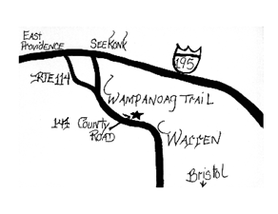
On parle francais.
Se hable espanol.
Falo português.

Contact Us at the Following:
147 County Rd. Suite 301A
Barrington, RI 02806
Phone: 401-643-1776
Fax: 401-694-0965
Email: DrMcVay@McVayPhysicalTherapy.com
Website:
www.mcvayphysicaltherapy.com

We accept most insurances: Blue Cross/Blue Shield, United Health, Medicare, Tufts, Aetna, Cigna, Harvard Pilgrim

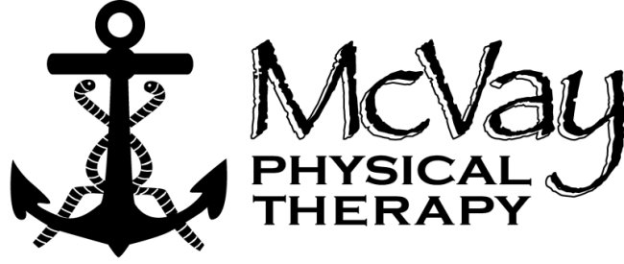
“Smooth Sailing Towards Less Pain”

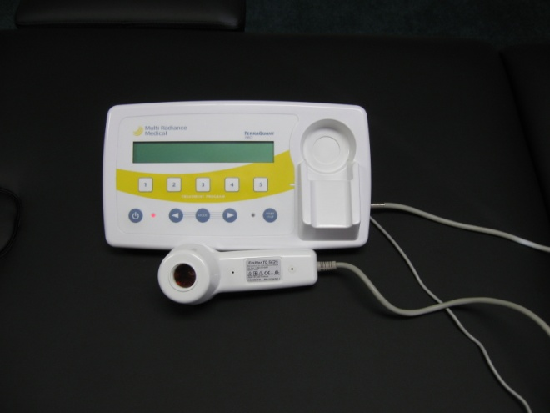

Cold Laser Therapy

This pamphlet was designed by
Cindy Larcher, PTA

LLLT (low light laser therapy) is commonly referred to as cold laser therapy and can be utilized to treat a variety of acute and chronic conditions including:
Osteoarthritis
Rheumatoid arthritis
Fibromyalgia
Low back, neck and shoulder pain
Myofascial pain syndromes
Tendonitis, sprains, strains
Nerve injuries, dental healing
Trigger points
What is laser therapy?
Low Level Laser Therapy utilizes non-thermogenic laser (gadolinium superpulsed laser), infrared light and visible red light emitting diodes (LED). The light can penetrate the tissue 2-5 cm. It is absorbed by cells resulting in increased cell processes, stimulating the cells.
Treatment time usually lasts for 5 minutes. The emitter is placed directly upon the skin over the area being treated. The laser may be kept in one spot or moved around depending on the size of the area being treated.
Increased circulation in the area treated will increase nutrients supplied to healing tissue. This has been shown to improve wound and tendon healing. Another benefit to the increased circulation in the localized area is the reduction of fluid buildup in the area, decreasing swelling. This can be very helpful when treating inflammatory conditions and acute injuries.
Research has shown LLLT useful in improving sensation and muscle control lost due to a nerve injury. Laser therapy has shown to help nerve injuries even if the injury occurred over 6 months prior to treatment.
Laser treatment helps to increase the release of your body’s endorphins. Endorphins are naturally occurring chemicals your body releases to reduce pain. This can decrease pain without medication.
Is it safe?
LLLT is FDA cleared technology that is used around the world. It is a non-invasive treatment with research supporting it.
It is utilized by the LA Kings, Tampa Bay Lightening , Kansas City Royals, and Waterville Valley Ski Academy.
Is there any condition that would prevent you from receiving laser therapy treatment?
It is recommended that pregnant women refrain from LLLT. The laser should not be used near the heart if you have a pacemaker or with active cancer.
Patient Testimonial:
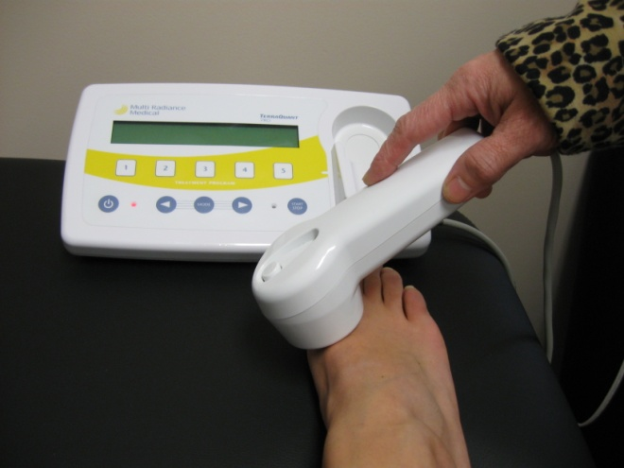

“The laser light treatment helped reduce pain I had following toe surgery. I was able to start wearing a shoe again!”

