About Us:

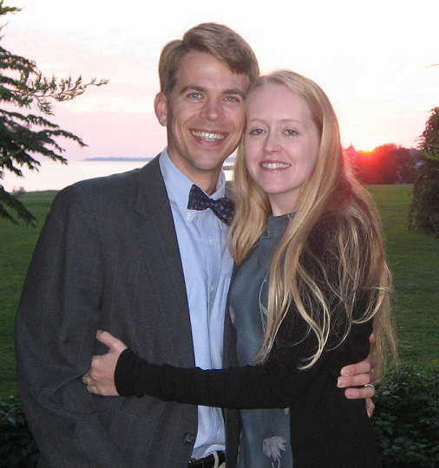

Dr. Jeremy McVay is the owner and director of McVay Physical Therapy. Dr. McVay has over 10 years of experience in treating patients with many diagnoses. He received a Bachelor of Science degree in Chemistry with a minor in French. He completed his Masters in Physical Therapy at East Carolina University and went on to finish his Doctorate with Distinction at Simmons College in Boston. In 2009, he became a certified strength and conditioning specialist (CSCS).

McVay Physical Therapy is located in Barrington, RI on 114 across from the Shaws Plaza. We are now handicapped accessible via an elevator on the second floor.
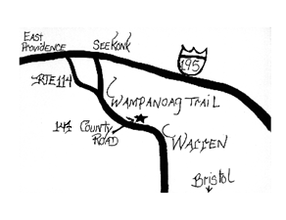
On parle francais.
Se hable espanol.
Falo português.

Contact Us at the Following:
147 County Rd. Suite 301A
Barrington, RI 02806
Phone: 401-643-1776
Fax: 401-694-0965
Email: DrMcVay@McVayPhysicalTherapy.com
Website:
www.mcvayphysicaltherapy.com

We accept most insurances: Blue Cross/Blue Shield, United Health, Worker’s Comp., Medicare, Tufts, Aetna, Cigna, Harvard Pilgrim
“Smooth Sailing Towards Less Pain”

Vertigo
BPPV (Benign Paroxysmal Positional Vertigo)

The emphasis at McVay Physical Therapy is on individualized care with patient directed goals and specialized equipment to speed recovery.

Vertigo

Vertigo may include feelings of the “room spinning”, dizziness, nausea, vomiting and headaches.

There are many types of vertigo and it can have multiple causes.
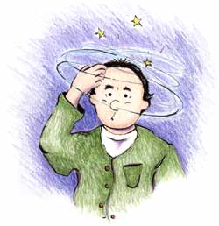

BPPV is a common type of vertigo that may be helped with treatment in physical therapy. It is caused by small calcium carbonate crystals, called otoliths that may break free from their place of origin (the cupula).

Sometimes this occurs without any reason.

The cupula is a pyramidal shaped surface that is in the vestibule which connects three semi-circular canals. These canals have a thick liquid inside which spins when your head moves in any direction. There are small hairs, called cilia, which move when this liquid moves. The loose otoliths can move and trick the hairs into sending signals that your head is moving when it is not. This usually occurs when lying down, getting up and rotating the head. It can be miserable.

Causes:

Otoliths may break free when the head is struck or moved quickly, such as with a roller coaster or a car crash.

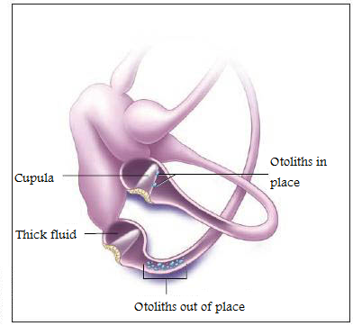

What do we do?

We take a thorough history to determine the chances that the vertigo is coming from BPPV.

Then tests may be performed to confirm this. Then treatment is performed to spin the otoliths back into position, near the cupula so that they may reattach.

It is important that you NOT move your head quickly, or lie your head down flat for36 to 48 hours after this treatment. This is critical to allow the crystals to reattach.

Medication can be helpful in numbing the brain to the feeling of vertigo, but does not correct the problem. The longer this problem goes on, the more difficult it can be to treat.

In Meniere's disease another problem, the increased inner ear fluid (endolymph) pressure can be corrected. This is a separate problem.

