About Us:

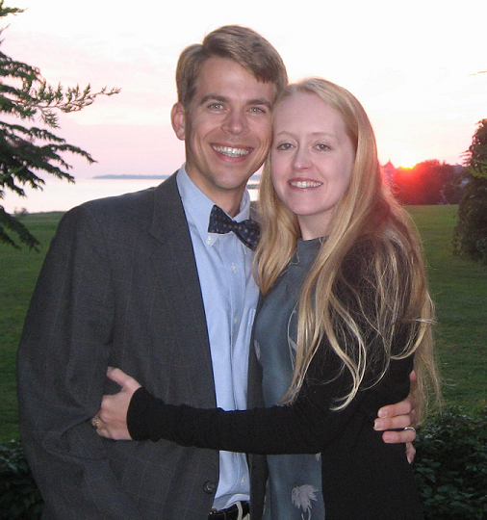

Dr. Jeremy McVay is the owner and director of McVay Physical Therapy. Dr. McVay has over 10 years of experience in treating patients with many diagnoses. He received a Bachelor of Science degree in Chemistry with a minor in French. He completed his Masters in Physical Therapy at East Carolina University and went on to finish his Doctorate with Distinction at Simmons College in Boston. In 2009, he became a certified strength and conditioning specialist (CSCS).

McVay Physical Therapy is located in Barrington, RI on 114 across from the Shaw’s Plaza. We are now handicapped accessible via an elevator on the second floor.
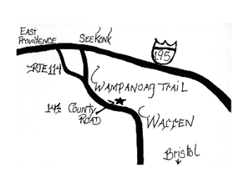
On parle francais.
Se hable espanol.
Fallo portuguese.

Contact Us at the Following:
147 County Rd. Suite 301A
Barrington, RI 02806
Phone: 401-643-1776
Fax: 401-694-0965
Email: DrMcVay@McVayPhysicalTherapy.com
Website:
www.mcvayphysicaltherapy.com

We accept most insurances: Blue Cross/Blue Shield, United Health, Worker’s Comp., Medicare, Tufts, Aetna, Cigna, Harvard Pilgrim
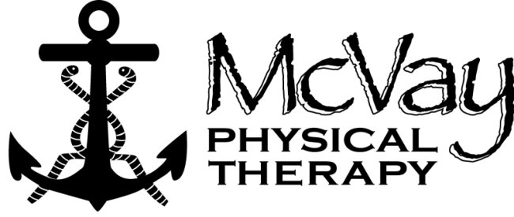
“Smooth Sailing Towards Less Pain”

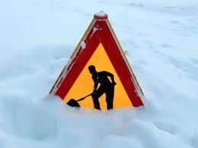

Snow Shoveling

The emphasis at McVay Physical Therapy is on individualized care with patient directed goals and specialized equipment to speed recovery.

Shoveling Snow Advice:

A walk before helps warm up your muscles and helps to prevents injury. Dress properly, noting that shedding some layers as you get warm may be necessary. Make sure you stay hydrated. It is easy to forget to drink enough water during the winter months.

Choose a shovel with a bent handle to reduce the need to bend forward. This helps you to push snow (do this whenever possible). A shovel should be lightweight with a small blade, remember that a shovel full of snow can weigh up to 20 pounds! The bigger the blade, the heavier the load is.

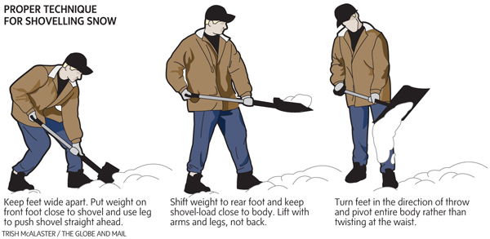

If you must lift the snow, lunge to scoop the snow and let your legs lift for you (or bend your knees in a squat). Lift only what you have to and dump the snow in front of you. Keep your back
straight, stomach tight and stick your
buttocks out. Do not twist! Take many small trips with frequent rests at a consistent rate (take layers off of deep snow). Do not throw snow over your shoulder. Keep the shovel (and snow) close to you with your hands spread apart on the handle.
Research done in Massachusetts demonstrated that the ideal load of snow per shovel-full is eleven to fifteen pounds. Each shovel stroke should take four to five seconds, or 12 to 15 strokes per minute. Snow should not be thrown more than three feet away (remember walking and dropping it is less strain).

Stretching after is best. Stretching exercises are patient specific- please ask for a program appropriate for you.

A newer invention is a rolling snow shovel or wheeled snow shovel, more expensive, but great for pain!
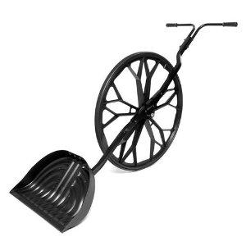
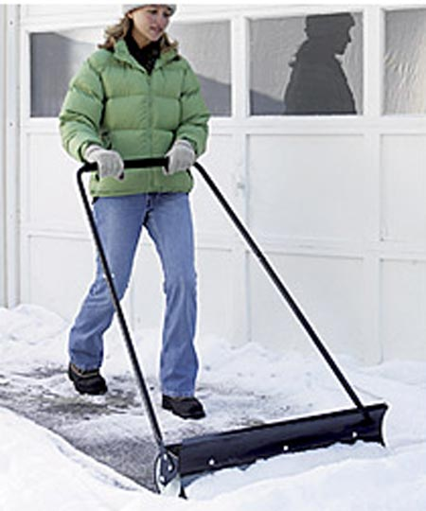

Shoulder, back and neck injuries are common. Do not ignore pain!

Take it slow, take breaks and listen to your body!

We, at McVay Physical Therapy, design custom programs for injury prevention for all activities and sports depending on the patient and conditions.

Finally, you could follow advice from a patient: “Hire someone else to do it!”

