Treatment:

- Treatment is patient specific- the shoulder is a very complicated joint and sensitive
- Treatment should minimize pain
- Treatment may include:
  - Stabilization- exercises to strengthen the rotator cuff
  - Posture correction- reducing the “impingement” by physical change
  - Ultrasound- deep heat/sound treatment used to treat muscles/tendons deep inside
- Surgery is the last resort, but sometimes necessary. It tends to be painful, but usually works very well.

Videos of specific surgeries can be found at: www.drgartsman.com/patient_resources/videos.asp

References:
Gray’s anatomy

McVay Physical Therapy is located in Barrington, RI on 114 across from the Shaws Plaza. We are now handicapped accessible via an elevator on the second floor.
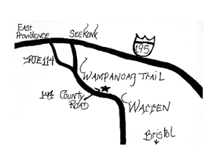
On parle francais.
Se hable espanol.
Fallo portuguese.

Contact Us at the Following:

147 County Rd. Suite 301A
Barrington, RI 02806
Phone: 401-643-1776
Fax: 401-694-0965

www.mcvayphysicaltherapy.com

We accept most insurances: Blue Cross/Blue Shield, United Health, Worker’s Comp., Medicare, Tufts, Aetna, Cigna, Harvard Pilgrim

“Smooth Sailing Towards Less Pain”

Rotator Cuff tendonitis, tears and impingement

This pamphlet was designed by

Jeremy McVay, DPT, CSCS, MPT, BS

Doctor of Physical Therapy

Anatomy:
The rotator cuff (RTC) comprises four small muscles that control movements of the shoulder. These include the supraspinatus (most frequently injured), infraspinatus, teres minor and subscapularis (occasionally teres major is included in the RTC). This is a view of the back of a shoulder:

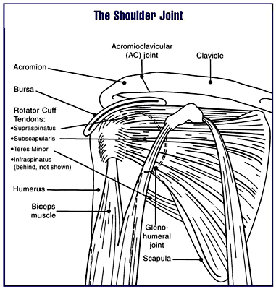

A thorough evaluation is needed to determine the type of injury and treatment that is appropriate. Tests (x-rays/MRIs) are a helpful part of this.

Tendonitis/
Impingement:
Tendonitis is an inflammation of the rotator cuff tendon(s). It commonly happens with repetitive overuse (pitching, overhead lifting), but also can occur with disuse. It commonly causes pain down the outside of the upper arm that moves toward the elbow (as well as shoulder pain).

Bones:
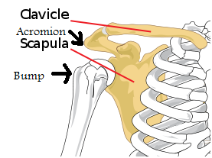
Impingement is when the bump on the outer humerus pinches the rotator cuff against the acromion. You can see the arrows above and how they might hit when the arm is raised overhead. This can cause “bursitis” as well (see bursa on first diagram). Difficulty sleeping is a common complaint.

Rotator Cuff Tear:
MRI:
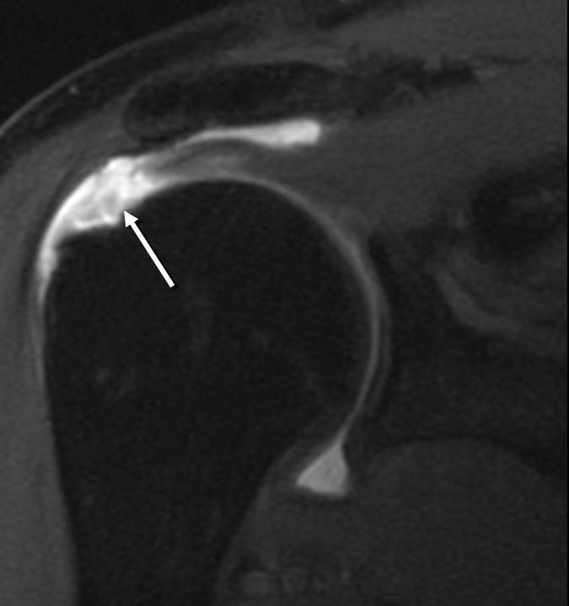
A rotator cuff tear is when the tendon or muscle is torn. It can be torn partially or completely and this can be extremely painful. A partial tear is treated similar to tendonitis. A full tear is irreversible and requires surgery to be repaired. A person with a full tear usually has trouble lifting their arm above their shoulder. A small percentage of people can manage without surgery, but with permanent limitations. MRI is used to diagnose a full tear.
Bicipital tendonitis:
The long head of the biceps can become inflamed or torn (see first diagram). This usually causes pain with lifting and raising the arms to the front.

